University of Pittsburgh at Johnstown

Electrical and Computer Engineering Department SENIOR DESIGN COE1199

Cycle Statistic Tool

Weekly Memorandum
To: | Maddumage Karunaratne
From: | Jacob Hoffman  Cody Klingler

cc:
Date: | 04/13/2021

Re:

Achievements:

Cody: Testing the new event-based software design was successful. The bluetooth characteristics are now much easier to update, and do so asynchronously.

Jacob: We have tested the list of discoverable devices for bluetooth and are able to search and discover the Cycle Statistic Tool. Additionally, data binding was set up for the trip page so that any time a property within the recorded entry sent from the CST is updated, it will automatically update the UI on the page. The code for the CST’s characteristics being sent over BLE is set up, but we have yet to fully test it.

Issues Encountered and Solved:

Cody: The strain gauge circuit had to be converted to a half-bridge design because one of the gauges in the full-bridge failed, which means that the time spent on redundancy was worth it. A lot of the time spent working this week was troubleshooting the GPS. It was not returning values other than 00.00000 when it was added to the new codebase. This was fixed by reading each byte of incoming data. The GPS library that we are using doesn’t note that this is necessary for the incoming data to be parsed and the example code makes it appear as if it is only for debugging.

Jacob: There was a persistent issue with the trip page not dynamically updating whenever it changed, but this was resolved through the implementation of the INotifyPropertyChanged interface, which requires the class to implement the OnPropertyChanged() method. This method is called any time a monitored property’s value is set and will cause the UI to automatically update the changes made. This functionality is also being implemented on the Goals page from earlier now.

Issues Encountered and Unresolved:

Cody: The GPS code has a new issue where updating bluetooth values causes a crash. None of my other bluetooth characteristics have ever crashed like this, so this is rather unexpected. I have installed the Arduino IDE’s beta version because it includes a real debugger. Hopefully this will provide more clues as to why this is happening.

Jacob: We have begun testing the bluetooth communications. Immediately, we started getting a run-time error. Although we have not spent much time diagnosing this issue yet, we believe the application is successfully connecting to the CST’s service, but is failing when running the code for the characteristics. Additionally, after implementing the data binding on the Goals page, a run-time error began occurring on the line that is initially populating the list of saved goal profiles provided from the SQLite database. This list is then used in the UI to show the user all the existing goal profiles. I don’t know why this is occurring, but I am going to try re-writing some of the database code/goals view model to try and resolve this.

Goals and Tasks For Next Week:

Cody: The plan for the remaining time is to make the project as presentable as possible for our demonstration on the 20th of April. This includes fixing the GPS crash problem, updating the secondary microcontroller code, completing display code, and finalizing the mounting of hardware.

Jacob: The project team is going to continue testing bluetooth communications until we can dynamically reflect the values being read on the CST hardware onto the smartphone application. Once this is completed, we can save trips. Then, we need to implement graphing on the Performance page.

Project Schedule:

Cody: The hardware path is behind schedule. I don't expect to be able to do any of the wind sensing in time for our demonstration. The rest of the project time will be spent on finishing up existing hardware and software for the 20th, as well as testing bluetooth with Jake.

Jacob: The mobile application path is still behind. We still have some coding to do, although the major functionality of the project has been implemented. We need to finish testing bluetooth communications, which should have been finished on 04/12/21. The application is constantly having new code added, but at this stage, the features we are implementing feel as if they are assisting us solely with fleshing out user experience and not core functionality. I would say that we are not too far behind, even though coding the mobile application is technically still not completed.

Project Logbook:

Cody:

4/5/2021 - 7.75 hours
I reconfigured old microcontroller code for the third monthly demonstration. Jake and I recorded our presentation and demonstrations. one of the strain gauges broke, so i had to trouble shoot that and then convert our design to a half bridge.

4/7/2021 - 5.0 hours
wrote the main for the primary microcontroller. the majority of this time was spent fixing compiler errors for the classes i previously created. The arduino IDE is not very good and makes compiling a pain. I've been experiencing hardware issues like the arduino not being detected on USB ports

4/9/2021 - 6.25 hours
I did a test run of the primary microcontroller. the code was bug free and only needed slight adjustments, except the GPSEvent class, which is not retrieving data from the GPS. Around half of this time was spent troubleshooting GPS issues.

4/10/2021 - 5.0 hours
All of this time was spent troubleshooting the GPS code, which is still not working. for some reason accessing the GPS object directly gives different results from accessing it through a pointer. Directly gives 0.000000 values, pointer gives overflows and really large values.

4/11/2021 - 0.0 hours
Disassembled the project and brought it to Jake's apartment in Johnstown. This will let us debug bluetooth and present our project in person.

4/12/2021 - 6.5 hours
Fixed the issue which prevented the GPS from giving values by printing the incoming data. Apparently the parser needs you to read the data byte by byte before it can register the new information, but the library doesn't tell you that. Now the microcontroller crashes when i update the bluetooth value for latitude. None of the other bluetooth values have caused a crash, so I'm not sure what the problem could be. I will do more testing tomorrow. The arduino IDE Beta has a debugger, so i will try to configure that to see if it will give reasons for the crash.

Jacob:

04/05/21 - 6 hours

I spent a lot of time today writing code for implementing bluetooth connectivity. I still haven’t tested, but I have set up methods for connecting to the characteristics under the main CST service. I have also set up methods for beginning characteristics updating, but I am concerned that my code is not correct. I ended up moving on to continuing with setting up the Trip page. I had to re-do the way I had binding set up to allow dynamic updating. This was done using an interface built into C# called INotifyPropertyChanged, which makes you implement a method called OnPropertyChanged(). Subsequently, this method is called any time you set a property that must be updated on the UI. I will also need to re-write the Goals page’s data binding to implement these features.

04/06/21 - 8 hours

Today mainly involved setting up the project for the SPACE conference on 04/07/21. This has involved finishing our monthly report, monthly presentation, and project demonstration video. Additionally, we worked on the project earlier in the day until we felt it was in a stable state to demonstrate some of the functionality we had implemented over the last month. This mainly included searching for bluetooth devices from the application, new layout updates to the application, demonstration of torque-applied-to-pedal measurements and operating physical display.

04/11/21 - 6 hours

I continued to work on the data binding for the Trip page and Goals pages. I have finished the Trip page, but I am still working on the Goals page as I am writing this. The UI on the Trip page is binded to a data model that has properties for all of the data we are sending over bluetooth from the CST. Whenever any value is updated/set in this data model, it will automatically update the Trip page UI. The same effect will occur in the Goals page, but it will also bind in two-way mode, meaning it will also be able to write to the data model (this page allows us to create new goal profile entries). Notably, Cody brought his equipment and the CST to my apartment today.

04/12/21 - 4 hours

I worked on the Goals page binding, but I am getting a run-time error whenever I try to load in the existing goal profiles from the application database. I believe there is an issue with the way I have my database set up, but I do not know how to resolve this issue. It is throwing a Null Reference Exception on the line of code that is trying to add the items from the database (the saved goal profile data models) into a list. Additionally, I collaborated with Coday a little bit with bluetooth connectivity. We are able to search and detect the CST device. It looks like we are able to connect to the service and see the characteristics, but the program currently crashes whenever the device tries to begin reading the values from the hardware.

Task Division:
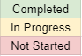
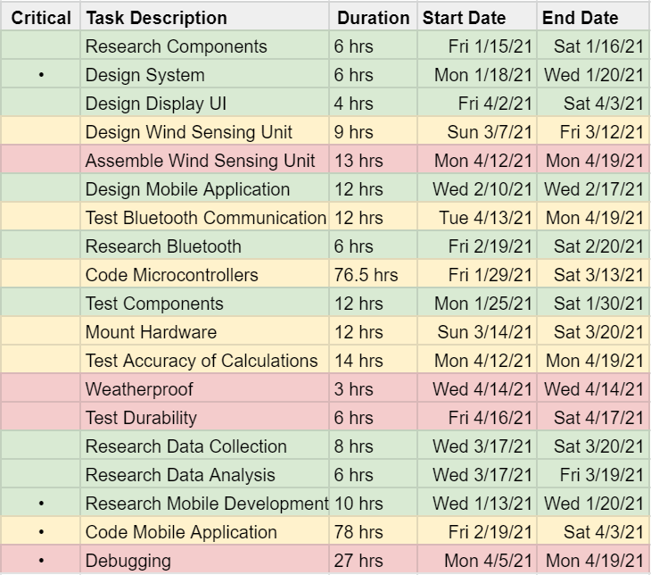
GANTT Chart:

